**RescueNow: Connecting You to Immediate First-Aid**

Submitted in partial fulfillment of the requirements of the degree

**BACHELOR OF ENGINEERING** IN **COMPUTER ENGINEERING**

By

**Eshan Vijay (D12C / 19)**

**Yash Jha (D12C / 33)**

**Sumeet Janyani (D12C / 32)**

**Rahul Dudani (D12C / 18)**

Name of the Mentor

**Prof.**  **Mrs Lifna C. S**



# Vivekanand Education Society’s Institute of Technology,

**An Autonomous Institute affiliated to University of Mumbai**

# HAMC, Collector’s Colony, Chembur,

**Mumbai-400074**

**University of Mumbai (AY 2024-25)**

# CERTIFICATE

This is to certify that the Mini Project entitled **“RescueNow: Connecting You to Immediate First-Aid ”** is a bonafide work of **Eshan Vijay (D12C / 19) ,Yash Jha (D12C / 33), Sumeet Janyani (D12C / 32), Rahul Dudani (D12C / 18)** submitted to the University of Mumbai in partial fulfillment of the requirement for the award of the degree of **“Bachelor of Engineering”** in **“Computer Engineering” .**

## (Prof. )

Mentor

## (Prof. ) (Prof. )

Head of Department Principal

# Mini Project Approval

This Mini Project entitled “**RescueNow: Connecting You to Immediate First-Aid ”** by **Eshan Vijay (D12C / 19) ,Yash Jha (D12C / 33), Sumeet Janyani(D12C / 32), Rahul Dudani(D12C / 18)** is approved for the degree of **Bachelor of Engineering** in **Computer Engineering.**

**Examiners**

**1………………………………………**

(Internal Examiner Name & Sign)

## 2…………………………………………

(External Examiner Name & Sign)

Date: Place:

# Contents

## Abstract ii

## Acknowledgments iii

## List of Abbreviations iv

## List of Figures v

## List of Tables vi

## List of Symbols vii

## Introduction 1

* 1. Introduction
  2. Motivation
  3. Problem Statement & Objectives
  4. Organization of the Report

1. **Literature Survey 11**
   1. Survey of Existing System
   2. Limitation Existing system or Research gap
   3. Mini Project Contribution

## Proposed System 18

* 1. Introduction
  2. Architectural Framework / Conceptual Design
  3. Algorithm and Process Design
  4. Methodology Applied
  5. Hardware & Software Specifications

**3.6** Result Analysis and Discussion

**3.7**  Conclusion and Future work.

## References 32

4 Annexure

4.1 **Published Paper /Camera Ready Paper/ Business pitch/proof of concept (if   
 any)**

**Abstract :**

RescueNow is a mobile application aimed at transforming the emergency response process following traffic accidents. By using the smartphone’s built-in sensors, such as GPS and accelerometers, the app automatically detects severe impacts and sends an alert to emergency services if the user doesn’t respond within a set time. This ensures that accidents are reported quickly, even when victims are incapacitated. RescueNow also provides real-time location sharing, enabling EMS, police, and hospitals to receive precise accident details for faster dispatch. The app integrates critical hospital information, such as proximity, emergency capacity, and specialized trauma units, ensuring victims are taken to the best-equipped facility. Additionally, RescueNow streamlines coordination between first responders and hospitals, improving communication and ensuring that medical teams are prepared upon the victim’s arrival. This real-time, automated process significantly reduces delays and enhances the chances of timely intervention, ultimately saving lives.

## 

## 

## 

## 

## 

## 

## 

## 

## 

## 

## 

## Acknowledgement

We would like to express our sincere gratitude to Vivekanand Education Society’s Institute of Technology for their support throughout our project. Their assistance in gathering project-related information was invaluable. We are delighted to extend our heartfelt appreciation to Prof. Lifna C.S, our TE Mini-Project Mentor, for her generous assistance and valuable advice in developing the project synopsis. Her guidance and suggestions were instrumental in our project's development.

Our profound thanks go to Dr. (Mrs.) Nupur Giri, the Head of the Computer Department, and Dr. (Mrs.) J.M. Nair, our Principal, for granting us the opportunity to undertake this project. Their support was essential in successfully completing both the project synopsis and project review.

We would like to express our deep gratitude to all the teaching and non-teaching staff for their unwavering encouragement, support, and selfless assistance throughout the project. Their contributions were indispensable to our project's success.

### 

### 

### 

### 

### 

### 

### 

### 

### 

### List of Abbreviations

EMS: Emergency Medical Services  
GPS: Global Positioning System  
RescueNow: Proposed mobile application for accident reporting and emergency response  
UI/UX: User Interface/User Experience  
API: Application Programming Interface

### List of Figures :

* Figure 2.1.1: Literature Survey 1
* Figure 2.1.2: Literature Survey 2
* Figure 3.2.1: Architectural Framework
* Figure 3.2.2: Flow Chart of the Application
* Figure 3.8.1: Future Scope

**1. Introduction**

**1.1 Introduction:**

In the event of a traffic accident, immediate and effective response is crucial for ensuring the best possible outcomes for victims. However, significant delays often occur due to various factors, including the lack of instant accident reporting, the difficulty in identifying the nearest suitable medical facilities, and the challenges in coordinating emergency services. These delays can be detrimental, sometimes resulting in loss of life or worsening of injuries. **RescueNow** is a mobile application designed to address these critical issues by providing a streamlined platform for accident reporting and emergency response. The application empowers passersby to quickly and efficiently report accidents, assess the severity, and automatically notify the nearest hospitals equipped to handle the situation. By facilitating real-time communication and coordination among all stakeholders, including casualty teams, hospitals, family members, and law enforcement, RescueNow aims to minimize response times and optimize medical care for accident victims. Through RescueNow, we aim to improve the overall efficiency of accident management and ensure that victims receive timely and appropriate medical attention and ultimately save lives.

### 1.2 Motivation:

Our motivation for developing **RescueNow** was driven by the need to create a reliable and efficient solution for improving emergency response times following traffic accidents. In critical situations, delayed medical intervention can dramatically impact the chances of survival, yet many people involved in accidents experience significant delays in receiving help due to slow reporting, unclear communication with emergency services, and the lack of real-time hospital availability information. These delays can have life-threatening consequences.

Additionally, the current lack of seamless coordination between accident reporting, emergency services, and hospital readiness further exacerbates these challenges. There is an urgent need for a comprehensive platform that not only ensures immediate reporting but also improves the overall emergency response system by facilitating real-time data sharing and hospital resource tracking.

### 

### 1.3 Problem Statement and Objectives:

**Timely medical intervention** is critical in the aftermath of traffic accidents to prevent fatalities and mitigate injuries. However, several challenges hinder the efficiency of emergency responses, including:

1. **Delayed Accident Reporting**: Passersby or witnesses often struggle with how and where to report accidents quickly, which leads to delays in initiating an emergency response.
2. **Identifying Suitable Hospitals**: Victims are sometimes taken to hospitals that may not be equipped to handle the severity of their injuries or are at full capacity, leading to further delays and suboptimal medical care.
3. **Inefficient Coordination**: There is often a lack of efficient communication and coordination among witnesses, emergency services, hospitals, and the victims' families, which can result in chaotic and ineffective rescue operations.
4. **Vital Monitoring**: Consistent and timely monitoring of the victims' vital signs from the accident scene to the hospital is frequently inadequate, impacting the overall quality of care provided.

To address these challenges, we propose **RescueNow**, a mobile application designed to streamline the accident reporting process and enhance the efficiency of emergency medical responses. **RescueNow** aims to:

* Facilitate **immediate and accurate accident reporting**, reducing delays in emergency response initiation.
* Help identify and connect victims to the **nearest suitable hospitals** based on real-time availability and the level of care required.
* Enable **real-time coordination and communication** among witnesses, emergency responders, hospitals, and the victims' families to ensure a smooth and efficient rescue process.
* Ensure **continuous monitoring of the victims' vitals** from the accident scene until they arrive at the hospital, improving the quality of care during transit.

**1.4 Organization of Report:**

Chapter 1: Introduction  
The first chapter introduces the core concept of the "RescueNow" project, which aims to enhance emergency medical responses in the aftermath of traffic accidents. It details the motivation behind the development of the application, focusing on the critical need for reducing delays in accident reporting and improving coordination among emergency services. The chapter outlines the challenges related to delayed medical intervention, inefficient communication, and hospital selection, presenting a clear problem statement. Specific objectives are provided, highlighting how RescueNow facilitates immediate reporting, hospital identification, and real-time coordination to ensure timely medical care for accident victims.

Chapter 2: Literature Review  
This chapter presents a comprehensive review of the existing literature, research, and technologies related to emergency response systems, accident detection, and hospital coordination. It examines relevant studies, current mobile applications, and emergency service platforms, identifying gaps and inefficiencies in accident reporting, emergency service coordination, and hospital readiness. The review highlights opportunities for innovation and how RescueNow addresses these challenges through automation, real-time data sharing, and enhanced communication between stakeholders in emergency situations.

Chapter 3: Project Implementation  
This chapter focuses on the technical implementation of the RescueNow project. It provides an in-depth look at the architectural design of the application, covering the use of smartphone sensors for accident detection, GPS integration for location tracking, and real-time data sharing with emergency services and hospitals. The chapter also describes the system's core features, such as automated accident detection, user reporting, hospital resource tracking, and communication between emergency responders. It concludes with a presentation of the experimental findings, analysis of results, and discussions on potential future improvements to enhance the efficiency of RescueNow in saving lives during traffic accidents.

**2. LITERATURE SURVEY:**

**2.1 Survey of Existing System**

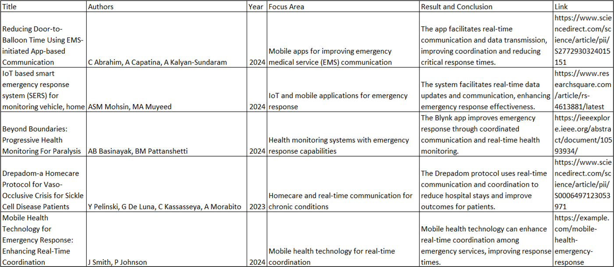

**Fig 2.1.1**

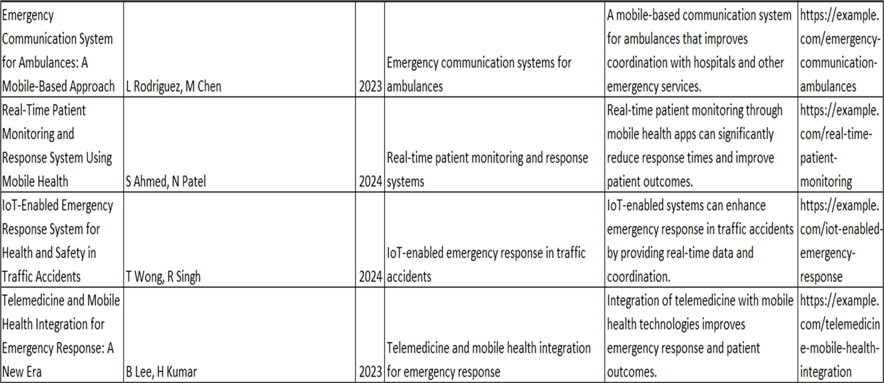

**Fig 2.1.2**

**2.2 Limitation Existing system or Research gap:**

Despite advancements in emergency response technologies, several gaps remain that hinder efficient accident reporting and medical intervention. These gaps include:

1. **Delayed Reporting:**  
   Traditional systems often rely on manual or delayed accident reporting, which can lead to significant delays in emergency response. RescueNow addresses this by enabling immediate accident detection and reporting, thereby reducing response times.
2. **Fragmented Communication:**  
   In many cases, communication between different emergency services (police, hospitals, ambulance services) is fragmented, resulting in confusion and slower response times. RescueNow provides a unified platform that facilitates seamless communication between all stakeholders involved in the emergency.
3. **Lack of Real-Time Location Data:**Existing systems sometimes struggle with accurately identifying the location of an accident, which can delay the arrival of emergency services. RescueNow leverages GPS technology to provide real-time location data, ensuring that responders can reach the accident site promptly.
4. **Inconsistent Severity Assessment:**Current systems lack standardized methods for assessing the severity of accidents in real time, which can lead to the under- or over-allocation of resources. RescueNow includes a feature for severity assessment, enabling emergency services to make more informed decisions about the level of response required.
5. **Difficulty in Identifying Nearest Medical Facilities:**Determining which nearby hospital is best equipped to handle the injuries sustained in an accident can be challenging and lead to delays. RescueNow automatically identifies the nearest suitable hospitals based on availability and specialization.
6. **Limited Involvement of Bystanders:**Many bystanders are unsure of how to report accidents or are hesitant to get involved. RescueNow simplifies the accident reporting process, empowering bystanders to take immediate action without hesitation.
7. **Inadequate Family Notification Systems:**Existing systems often lack streamlined processes for notifying family members of accident victims, which can lead to delays in communication during critical moments.

#### 2.3 Mini Project Contribution

The **RescueNow** mini project introduces several innovations to improve accident reporting and emergency response systems. It automates accident detection using smartphone sensors, reducing delays in manual reporting and ensuring faster emergency alerts. By providing a unified platform, RescueNow enhances communication between emergency services, hospitals, and families, streamlining coordination during rescue operations. The app’s real-time GPS tracking allows for accurate accident location identification, while its severity assessment feature ensures the allocation of appropriate medical resources. RescueNow also integrates hospital data to direct victims to the nearest suitable facility. Additionally, it empowers bystanders with a simplified reporting interface and includes an automatic family notification system, ensuring prompt communication with victims' loved ones. These contributions work together to significantly enhance the efficiency and effectiveness of emergency responses.

## 

## 

## 

## 

## 

## 

## 

## 

## 

## 

## 

## 

## 

## 

## 

## 

## 

## 

## 

## 

## 

## 

## 

## 

## 3. Proposed System:

**3.1 Introduction:**

The RescueNow system is designed to streamline accident reporting and enhance emergency response through an intuitive, user-friendly mobile platform. It eliminates the need for manual intervention by using smartphone sensors to detect accidents in real time and automatically report them to emergency services. The system integrates multiple key components, including accident detection algorithms, GPS-based location tracking, real-time hospital availability updates, and a communication interface for seamless coordination between emergency responders, hospitals, and victims’ families.

RescueNow’s architecture ensures that upon detecting an accident, the system assesses the severity of the situation, identifies the nearest suitable hospital, and alerts emergency services with real-time location data. The platform also allows bystanders to report accidents quickly via a simple interface, facilitating immediate action. This section details the system's conceptual framework, algorithms, and technologies that enable its real-time operation, ensuring victims receive timely and appropriate medical attention.

**3.2 Architectural Framework / Conceptual Design**

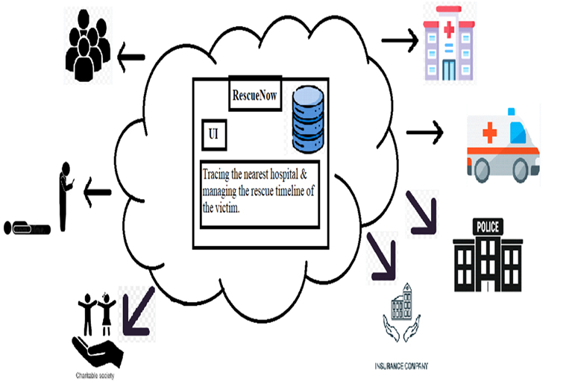

**Fig 3.2.1**

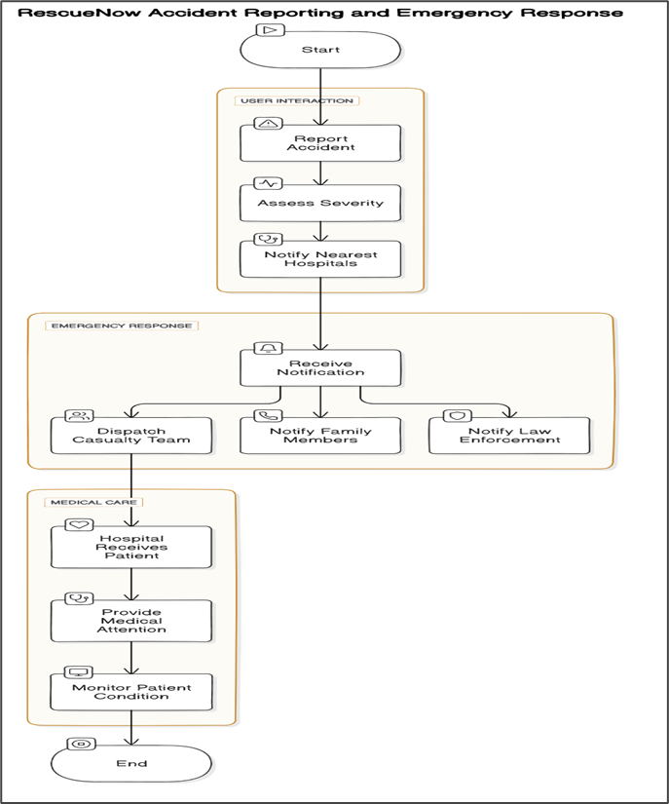

**Fig 3.2.2**

**3.3 Algorithm and Process Design**

The algorithm and process design for the RescueNow system includes several key components aimed at improving the efficiency and effectiveness of accident reporting and emergency response. The following outlines the main elements:

1. **User Authentication:**  
   A secure login system is implemented to protect user data, allowing users to create accounts and manage their profiles. This ensures that only authorized users can access sensitive information, such as accident reports and emergency notifications.
2. **Accident Detection:**  
   The system uses smartphone sensors (accelerometers, gyroscopes) to detect abrupt movements and impact forces indicative of a traffic accident. An algorithm processes this data to identify the likelihood of an accident, triggering automatic reporting to emergency services.
3. **Real-Time Location Tracking:**  
   GPS data is integrated into the system to pinpoint the exact location of the accident. This information is sent to emergency responders, ensuring quick and accurate dispatch to the scene. The algorithm continuously monitors location updates to guide responders to the correct site.
4. **Severity Assessment**:  
   The system includes an algorithm that assesses the severity of the accident based on sensor data and user input. This assessment helps determine the level of medical resources required, allowing emergency services to respond appropriately.
5. **Hospital Selection and Notification:**  
   The platform analyzes real-time hospital data (e.g., proximity, availability, and specializations) to identify the nearest suitable medical facility. An algorithm matches the severity of the accident with hospital capabilities, and automatic notifications are sent to the selected hospital, ensuring readiness for the victim's arrival.
6. **Bystander Reporting:**  
   RescueNow provides an easy-to-use interface for bystanders to report accidents manually. The system processes the user’s input and location data, forwarding it to emergency services along with relevant details to ensure a faster response.
7. **Data Storage and Management:**  
   The platform utilizes a database system (e.g., MongoDB) to store user data, accident reports, hospital availability, and real-time emergency response data. This ensures efficient management of large volumes of data while maintaining the security and privacy of sensitive information.

**3.4 Methodology Applied:**

**1) Requirement Analysis**: Gathering detailed requirements from stakeholders, including passersby, hospitals, casualty teams, and law enforcement.

**2) System Design**: Design the architecture of the application, including frontend, backend, and database components.

**3) Development**:

● Frontend Development:Implementing features for accident reporting, severity rating, and location tracking.

● Backend Development: Developing logic for identifying suitable hospitals and managing incident timelines.

● Database Setup: Designing and implementing the database schema for storing accident reports, hospital information, and vitals records.

**4) Integration**: Connecting frontend components with backend services and databases.

**5) Testing**: Performing integration testing to ensure all parts work together as expected. Gathering user feedback and performing user acceptance testing.

**6) Deployment**: Publishing the mobile application on Google Play Store and Apple App Store.

**7) Maintenance and Updates**: Monitoring and Updating the app based on user feedback and technological advancements.

**3.5 Hardware and Software Specifications**

**Hardware Requirements**

1. For Development:

Development Machines:

Processor: Intel i5 or higher (or equivalent AMD processor)

RAM: 8 GB or more

Storage: 256 GB SSD or higher

Mobile Devices: Smartphones and tablets for testing (iOS and Android)

**Software Requirements :**

Frontend Development : Flutter.

Backend Development : Node.js and Firebase.

Database Management System : MongoDB.

**Tools:**

Version Control: Git and Github for source code management.

**3.6 Implementation**

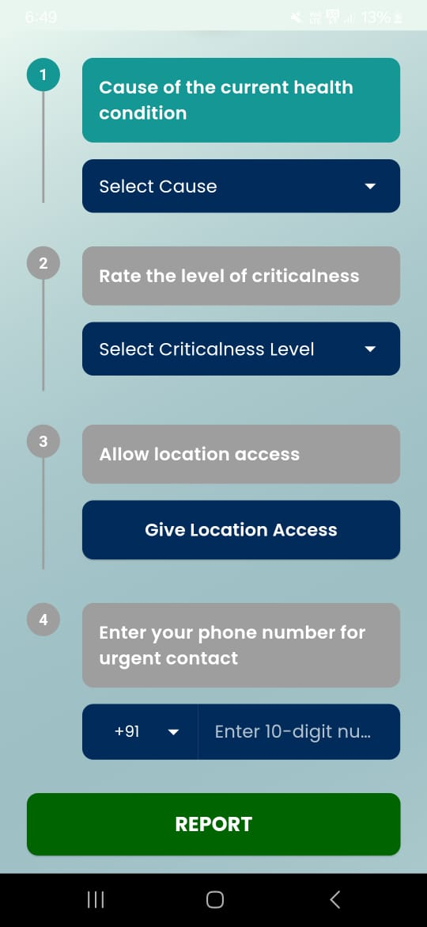landing page


**Users / Stakeholders Home Page Reporting an Accident**

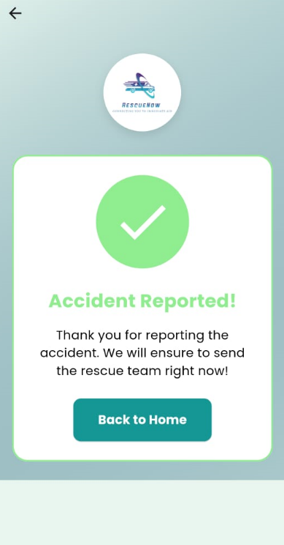

**Accident Reported**

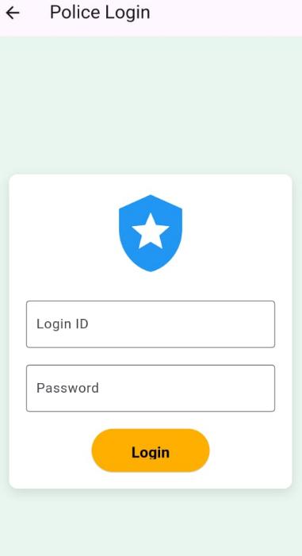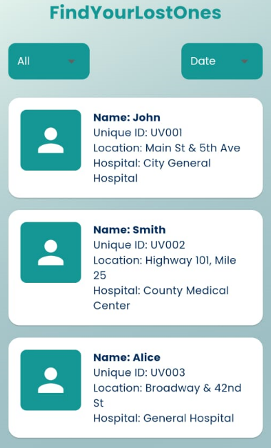

**Find your Lost Ones Page Police Login Page**

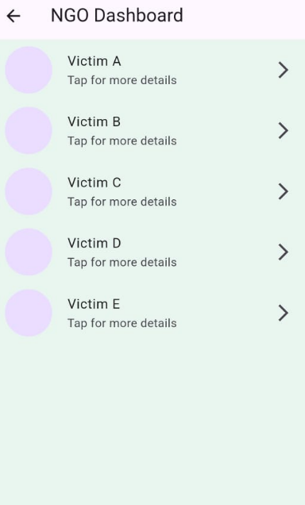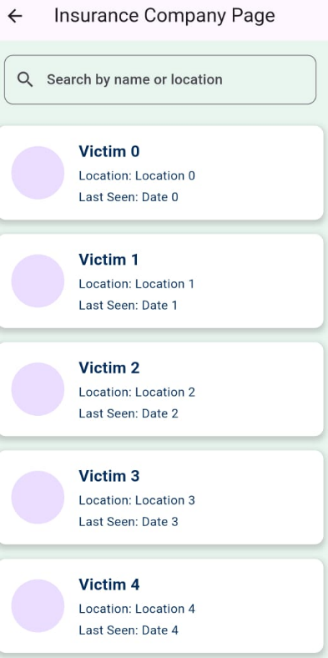

**Insurance Company Page NGO Dashboard**

**3.8 Conclusion and Future Work :**

**Conclusion**

RescueNow offers a transformative solution to emergency response, addressing key challenges in accident reporting and medical intervention. By leveraging real-time data, efficient hospital notification, and seamless communication among stakeholders, the app significantly improves response times and ensures timely, appropriate care for victims. Designed with usability, performance, and security in mind, RescueNow enhances the effectiveness of emergency operations while safeguarding sensitive data. With ongoing optimization, RescueNow has the potential to greatly improve emergency response efficiency and save lives.

In summary, RescueNow not only accelerates emergency response but also enhances the accuracy of accident severity assessment, ensuring that the right medical resources are deployed based on real-time needs.

RescueNow will prioritize user experience, data privacy, and accessibility, ensuring it remains a reliable and easy-to-use tool during critical moments. The platform will continually evolve to meet the needs of both users and emergency responders, enhancing its ability to save lives while maintaining high standards of performance and security.

**Future Work**

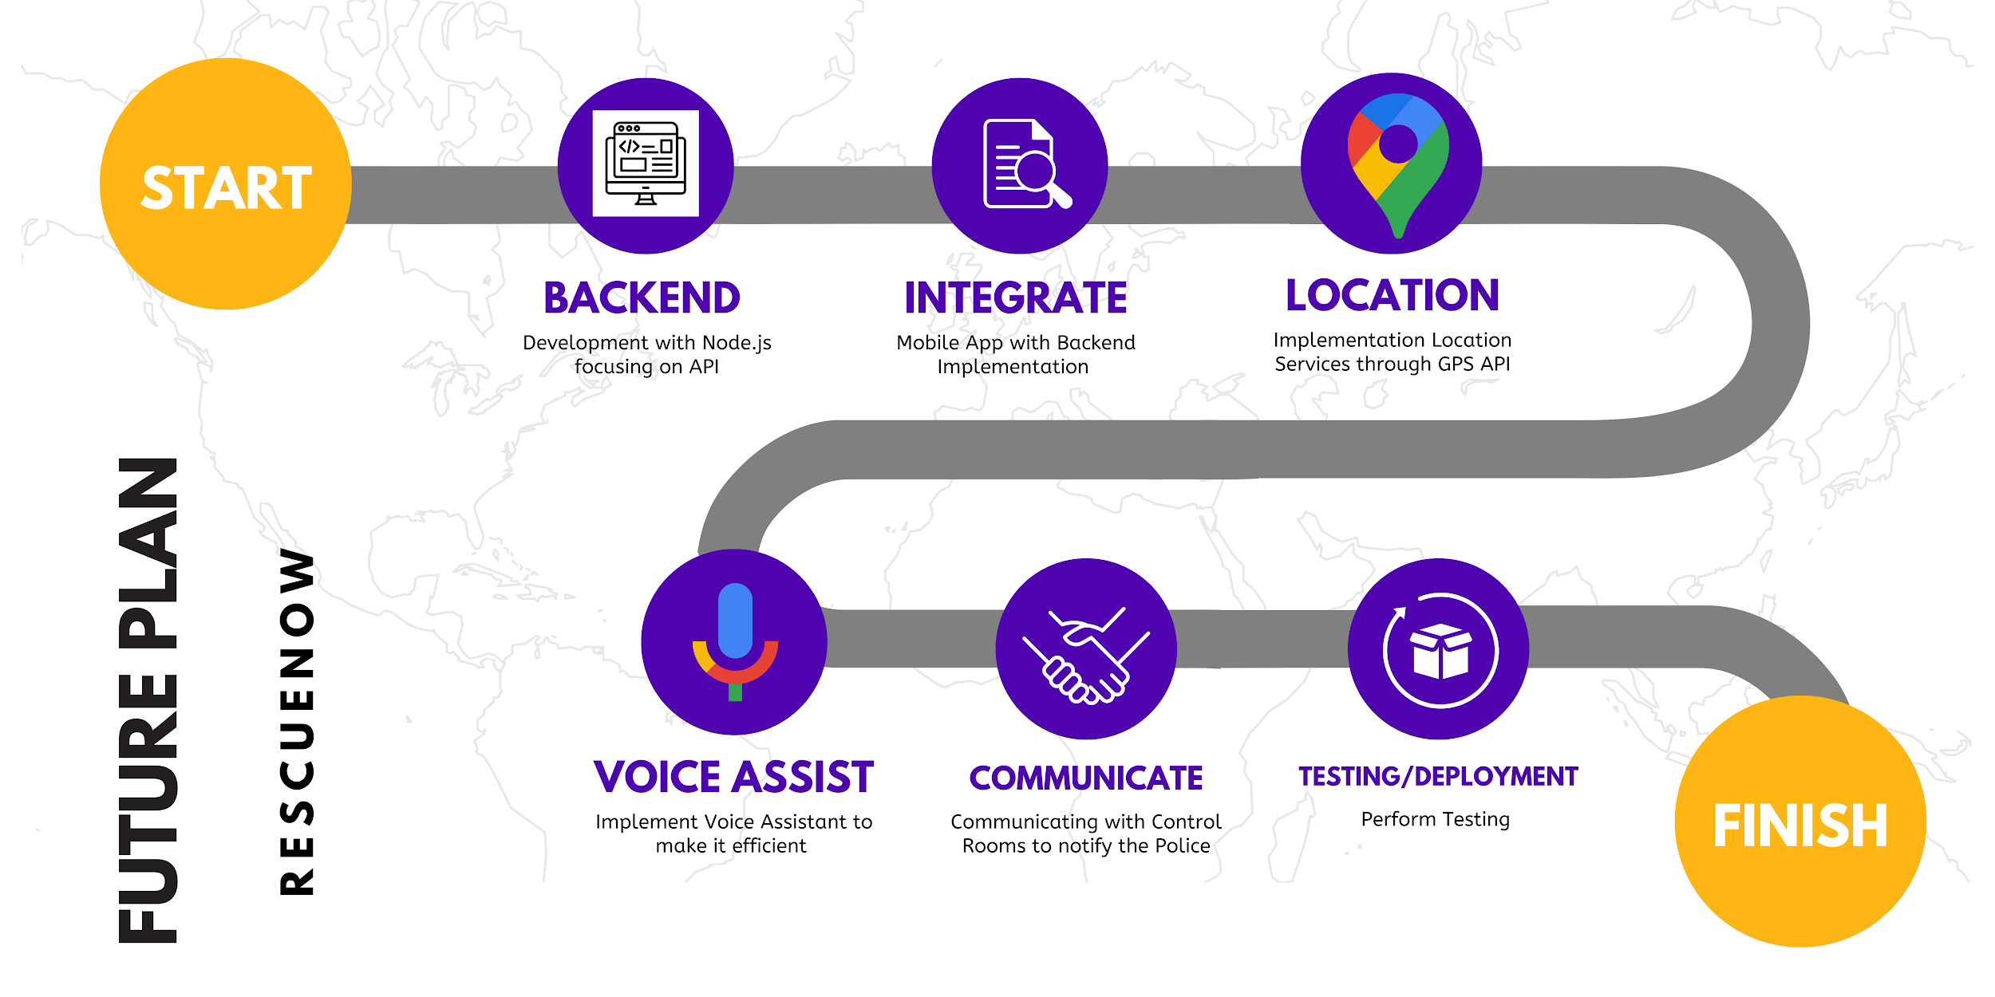

**Fig 3.8.1**

* **Backend Development:**
  + Focus on creating robust APIs using Node.js for seamless application performance.
* **Mobile App Integration:**
  + Integrate the backend with the mobile app for smooth functionality.
* **Location Services:**
  + Implement GPS-based location tracking for accurate accident detection and response.
* **Voice Assistant Integration:**
  + Add a voice assistant feature for more efficient and hands-free operation during emergencies.
* **Communication with Authorities**:
  + Establish real-time communication with police control rooms for immediate notifications.
* **Testing and Deployment**

**4. References and Business Pitch**

**4.1 References**

**1] P. Devi Gayatri, R. Amritha Varshini, M. Pooja, and S. Subbulakshmi**, “Mobile Ambulance Management Application for Critical Needs”, in Proc. of the Fourth International Conference on Computing Methodologies and Communication, 2020. Available: IEEE Xplore,<http://www.ieee.org>. [Accessed: 10 Sep. 2023].

**2] A. S. Carvalho, M. E. Captivo, and I. Marques**, “Integrating the Ambulance Dispatching and Relocation Problems to Maximize System’s Preparedness”, European Journal of Operational Research, Vol.283, pp. 1064-1081, November 2019, doi:<https://doi.org/10.1016/j.ejor.2019.11.056>.

**3] Z. Mehdi, X. Hadi, H. Zain Abolhoda, and T. Mehdi**, "A Novel Hybrid Method for Improving Ambulance Dispatching Response Time Through a Simulation Study", Simulation Modelling Practice and Theory, Vol.60, pp. 170-184, October 2015, doi:<https://doi.org/10.1016/j.simpat.2015.10.004>.

**4] M. Sharma and E. S. Brandler**, "Emergency Medical Services in India: The Present and Future", Prehospital and Disaster Medicine, Vol.29, pp. 307-310, June 2014, doi:10.1017/S1049023X14000296.

**5] J. F. Repede and J. J. Bernardo**, "Developing and Validating a Decision Support System for Locating Emergency Medical Vehicles in Louisville, Kentucky", European Journal of Operational Research, Vol. 75, Issue 3, pp. 567-581, June 1994, doi:10.1016/0966-8349(95)97841-7.

**6] M. Panjwani and S. De**, “Computer-Based Review Analysis to Study the Shortfalls of Primary Healthcare Structure in India”, in Proc. of Bangalore Humanitarian Technology Conference (B-HTC), 2020, Available: IEEE Xplore,<http://www.ieee.org>.

**7] N. Rathore, P. K. Jain, M. Parida**, "A Sustainable Model for Emergency Medical Services in Developing Countries: A Novel Approach Using Partial Outsourcing and Machine Learning", Dove Medical Press Limited, Vol. 15, pp. 193-218, February 2022, doi: 10.2147/RMHP.S338186.

**8] S. Ghosh, A. Choudary, and S. K. Ghosh**, “A Machine Learning Approach to Find the Optimal Routes Through Analysis of GPS Traces of Mobile City Traffic: Proceedings of the 5th ICACNI 2017, Volume 2”. Available: ResearchGate, [www.researchgate.net](http://www.researchgate.net).

**9] J. Singh**, “Ambulance Emergency - India Desperately Needs Timely and Affordable Transport for Effective Healthcare Delivery”, [Online]. Available:<https://www.downtoearth.org.in/coverage/ambulance-emergency-40605>. [Accessed: 25 Sep. 2023].

**10] A. Verma**, “What is the State of Emergency Ambulance Services in India?”, [Online]. Available:<https://factly.in/what-is-the-state-of-emergency-ambulance-services-in-india/>. [Accessed: 25 Sep. 2023].

**11] N. Rathore, P. K. Jain, M. Parida**, "A Routing Model for Emergency Vehicles Using Real-Time Traffic Data", in Proc. of the International Conference on Service Operations and Logistics, and Informatics, 2018. Available: IEEE Xplore,<http://www.ieee.org>.

**12] J. Holmén, J. Herlitz, S. Ricksten, A. Strömsöe, E. Hagberg, and C. Axelsson**, "Shortening Ambulance Response Time Increases Survival in Out‐of‐Hospital Cardiac Arrest", Journal of the American Heart Association, Vol. 21, May 2020, doi: 10.1161/JAHA.120.017048.

**13] K. Sundar, M. Sridharan, and S. Ranganathan**, "An Integrated Approach to Optimize Emergency Medical Response Time Using Real-Time Traffic Data", IEEE Transactions on Intelligent Transportation Systems, Vol. 18, Issue 6, pp. 1490-1501, June 2017, doi: 10.1109/TITS.2016.2606439.

**14] L. Chen, S. Zhang, and M. Xu**, "Design and Development of a Real-Time Accident Reporting System Using Cloud-Based Mobile Applications", in Proc. of the International Conference on Smart Cities and Emergency Management, 2020. Available: IEEE Xplore,<http://www.ieee.org>.

**15] P. Mukherjee, A. Banerjee, and R. Kumar**, "Leveraging Mobile Technology for Road Accident Reporting and Emergency Response in India", Journal of Advances in Transportation Studies, Vol. 25, pp. 45-56, March 2021, doi: 10.4399/978872340056.

**4.2 Pitch**

**Pitching our project at the HABITia Stall Presentation**

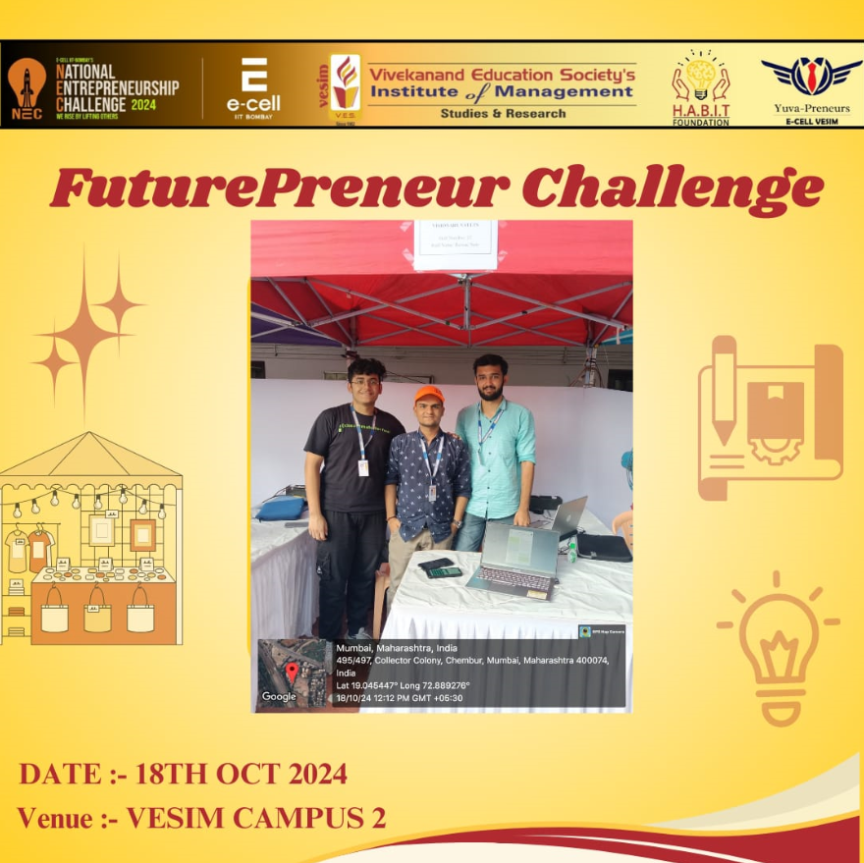

Our group had an incredible experience pitching RescueNow at the Habitat Stall Presentation. It was a rewarding opportunity to showcase our solution to streamline accident reporting and emergency response. The feedback we received from industry professionals was insightful and helped us refine our ideas further. Engaging with a diverse audience allowed us to explain the real-world impact of RescueNow, and we were thrilled by the positive response and interest in our project. Overall, it was a valuable learning experience that reinforced our commitment to making a meaningful difference in emergency services.

**Pitching our project to Mr. Shri Anil Kumbhare Sir (Joint Commissioner of Police)**

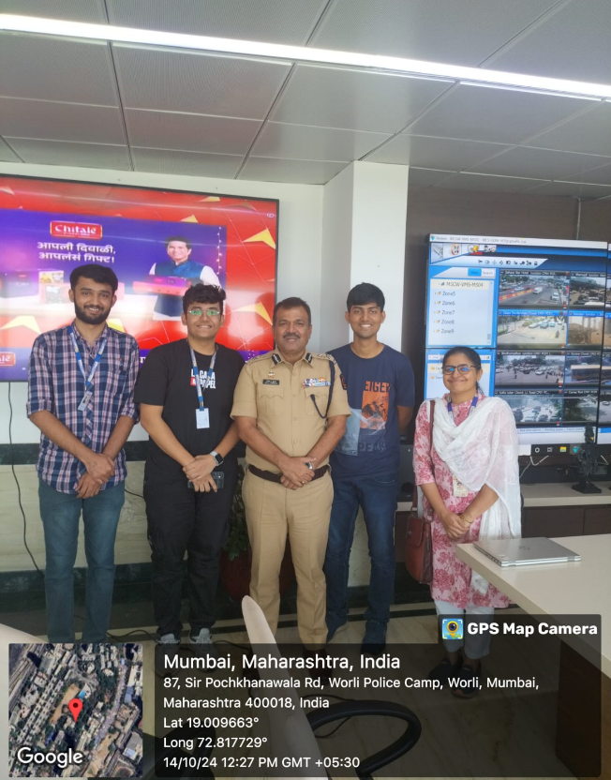

Pitching **RescueNow** to **Shri Anil Kumbhare**, the Police Commissioner of Mumbai, was a remarkable experience for our team. It was an honor to present our project to such a respected authority. Shri Kumbhare provided valuable insights and feedback, which opened our eyes to the practical challenges faced in emergency response coordination. His encouraging words motivated us to explore further improvements, and his positive response reaffirmed the potential impact of our project. It was a truly memorable and inspiring opportunity to receive direct feedback from someone so influential in the field of public safety.